# React

# 5.ReactJS-HOL

# Mandatory HandsOn

**My Academy team at Cognizant want to create a dashboard containing the details of ongoing and completed cohorts. A react application is created which displays the detail of the cohorts using react component. You are assigned the task of styling these react components.**

Download and build the attached react application.

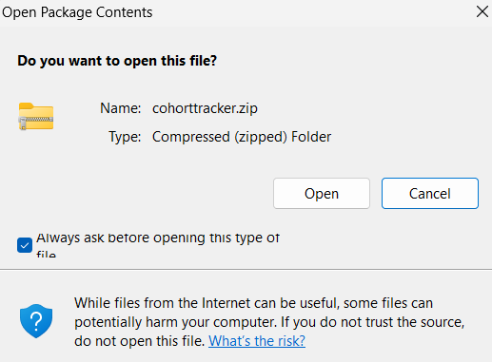

1. Unzip the react application in a folder
2. Open command prompt and switch to the react application folder

cd cohortstracker

1. Restore the node packages using the following commands

npm install

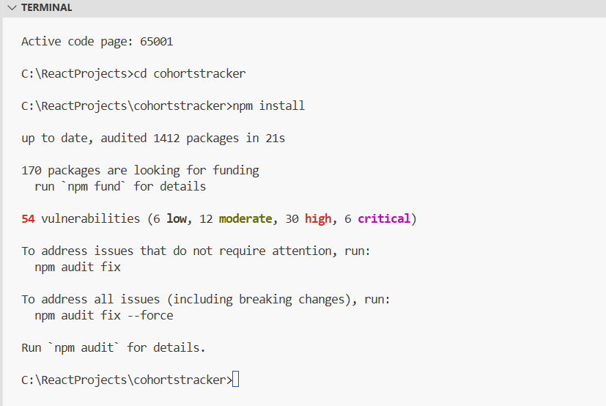

1. Open the application using VS Code

code.

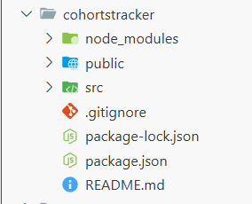

1. Create a new CSS Module in a file called “CohortDetails.module.css”

**CohortDetails.module.css**

/* Step 6 - Box styling */

.box {

width: 300px;

display: inline-block;

margin: 10px;

padding: 10px 20px;

border: 1px solid black;

border-radius: 10px;

}

/* Step 7 - Style <dt> element */

dt {

font-weight: 500;

}

/* Step 10 - Style <h3> based on cohort status */

.ongoing {

color: green;

}

.other {

color: blue;

}

1. Open the cohort details component and import the CSS Module

**CohortDetails.js**

import styles from './CohortDetails.module.css';

function CohortDetails(props) {

const { cohort } = props;

const headerClass = cohort.currentStatus === "Ongoing" ? styles.ongoing : styles.other;

return (

<div className={styles.box}>

<h3 className={headerClass}>

{props.cohort.cohortCode} -

<span>{props.cohort.technology}</span>

</h3>

<dl>

<dt>Started On</dt>

<dd>{props.cohort.startDate}</dd>

<dt>Current Status</dt>

<dd>{props.cohort.currentStatus}</dd>

<dt>Coach</dt>

<dd>{props.cohort.coachName}</dd>

<dt>Trainer</dt>

<dd>{props.cohort.trainerName}</dd>

</dl>

</div>

);

}

export default CohortDetails;

**Cohort.js**

class Cohort {

constructor(cohortCode,

startDate,

technology,

trainerName,

coachName,

currentStatus) {

this.cohortCode = cohortCode;

this.coachName = coachName;

this.trainerName = trainerName;

this.technology = technology;

this.startDate = startDate;

this.currentStatus = currentStatus;

}

}

const CohortsData =[

new Cohort('INTADMDF10','22-Feb-2022', '.NET FSD', 'Jojo Jose','Aathma', 'Scheduled'),

new Cohort('ADM21JF014','10-Sep-2021', 'Java FSD', 'Elisa Smith','Apoorv', 'Ongoing'),

new Cohort('CDBJF21025','24-Dec-2021', 'Java FSD', 'John Doe','Aathma', 'Ongoing'),

new Cohort('INTADMJF12','22-Feb-2022', 'Java FSD', 'To Be Assigned','Ibrahim', 'Scheduled'),

new Cohort('CDE22JF011','24-Dec-2021', 'Java FSD', 'Emma Swan','Apoorv', 'Ongoing'),

new Cohort('INTADMDF09','22-Feb-2022', 'Dataware Housing', 'Babjee Rao','Aathma', 'Scheduled'),

new Cohort('ADM22DF001','10-Sep-2021', '.NET FSD', 'Marie Curie','Ibrahim', 'Ongoing'),

];

export {Cohort, CohortsData};

1. Final result should look similar to the below image

npm start

